20170526 Vander T8-1.2-865 181608 20W T8 LED Tube Light Problem - Repair - Defective

100-240VAC 50/60Hz

Ebay

50% failure after 1 year

These tubes are made to run off of 120/220 volts supplied to opposite ends of the bulb. You remove the ballast and put 120 end to end. The ones you find at the store may be designed to work with an electronic ballast (pay more attention than I did).

This document is started to help those who bought defective lamps from ebay. In the last 2 weeks I lost all 4 of the unit I bought! Looks like the internal power supply failed. IC appears to have overheated (black area). They lasted about 6 months.

I am ordering replacement 20w replacement power units (will publish more info if successful).

These photos show the power adapter

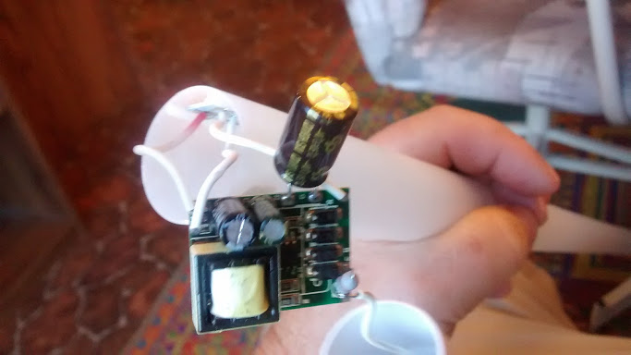

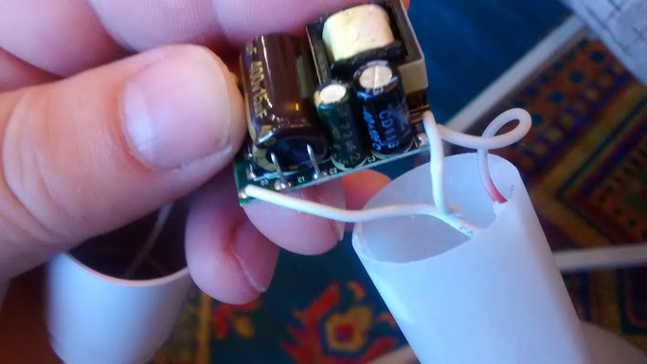

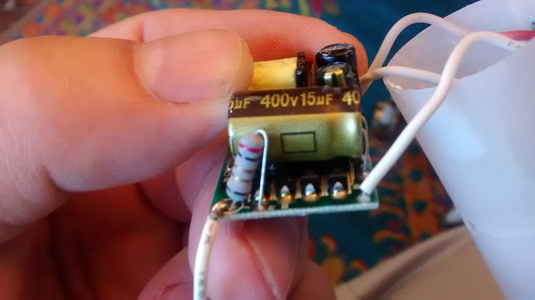

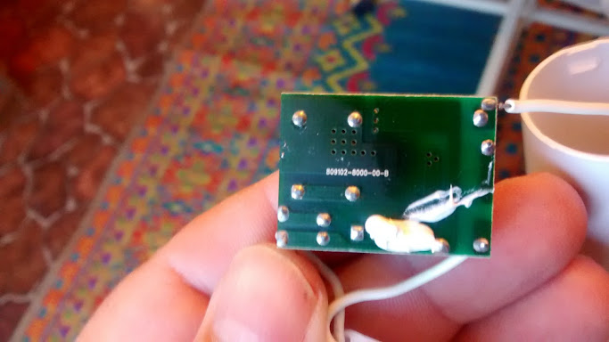

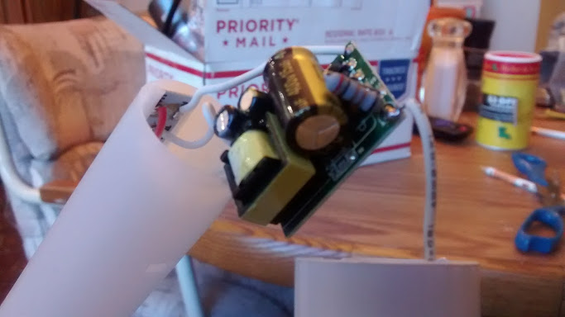

Potential replacement

